ultramirinc.champs_mood.fragments

Class MyAdapterFriend

java.lang.Object android.support.v7.widget.RecyclerView.Adapter<MyViewHolderFriend>

ultramirinc.champs_mood.fragments.MyAdapterFriend



public class MyAdapterFriend

extends android.support.v7.widget.RecyclerView.Adapter<MyViewHolderFriend>

Created by William on 2017­04­04. This class creates a binding between the raw data and the visual interpretation of a User for the current user's friends. This class binds it with a MyViewHolderFriend object.

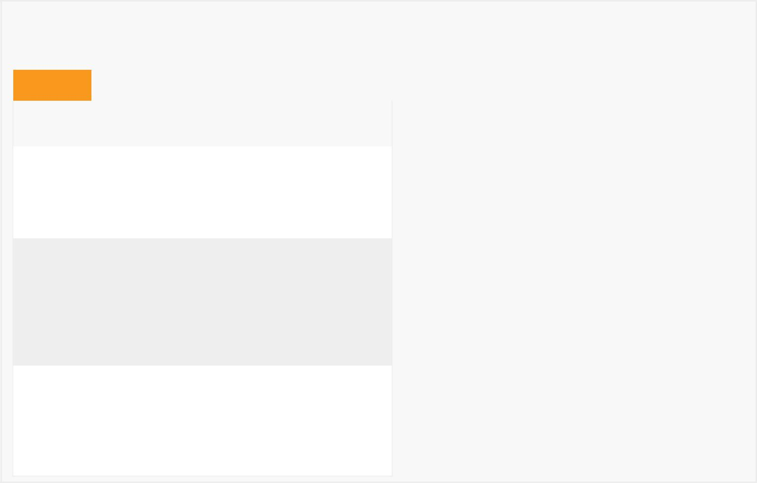

*Field Summary*

Fields

|  |  |
| --- | --- |
| Modifier and Type | Field and |
|  | Description |

private android.content.Context context

The context to the activity

private boolean isPokable

Determines if the friend can be poked or not

private java.util.List<User> list

Contains the list of the user's friends

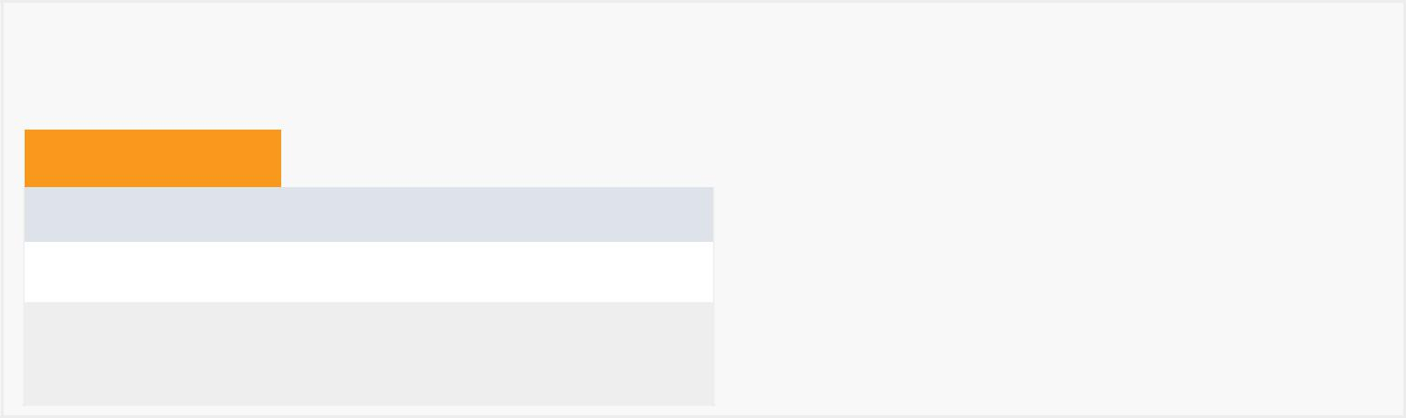

*Constructor Summary*

Constructors

Constructor and Description

MyAdapterFriend()

MyAdapterFriend(java.util.List<User> list, android.content.Context context)



*Method Summary*

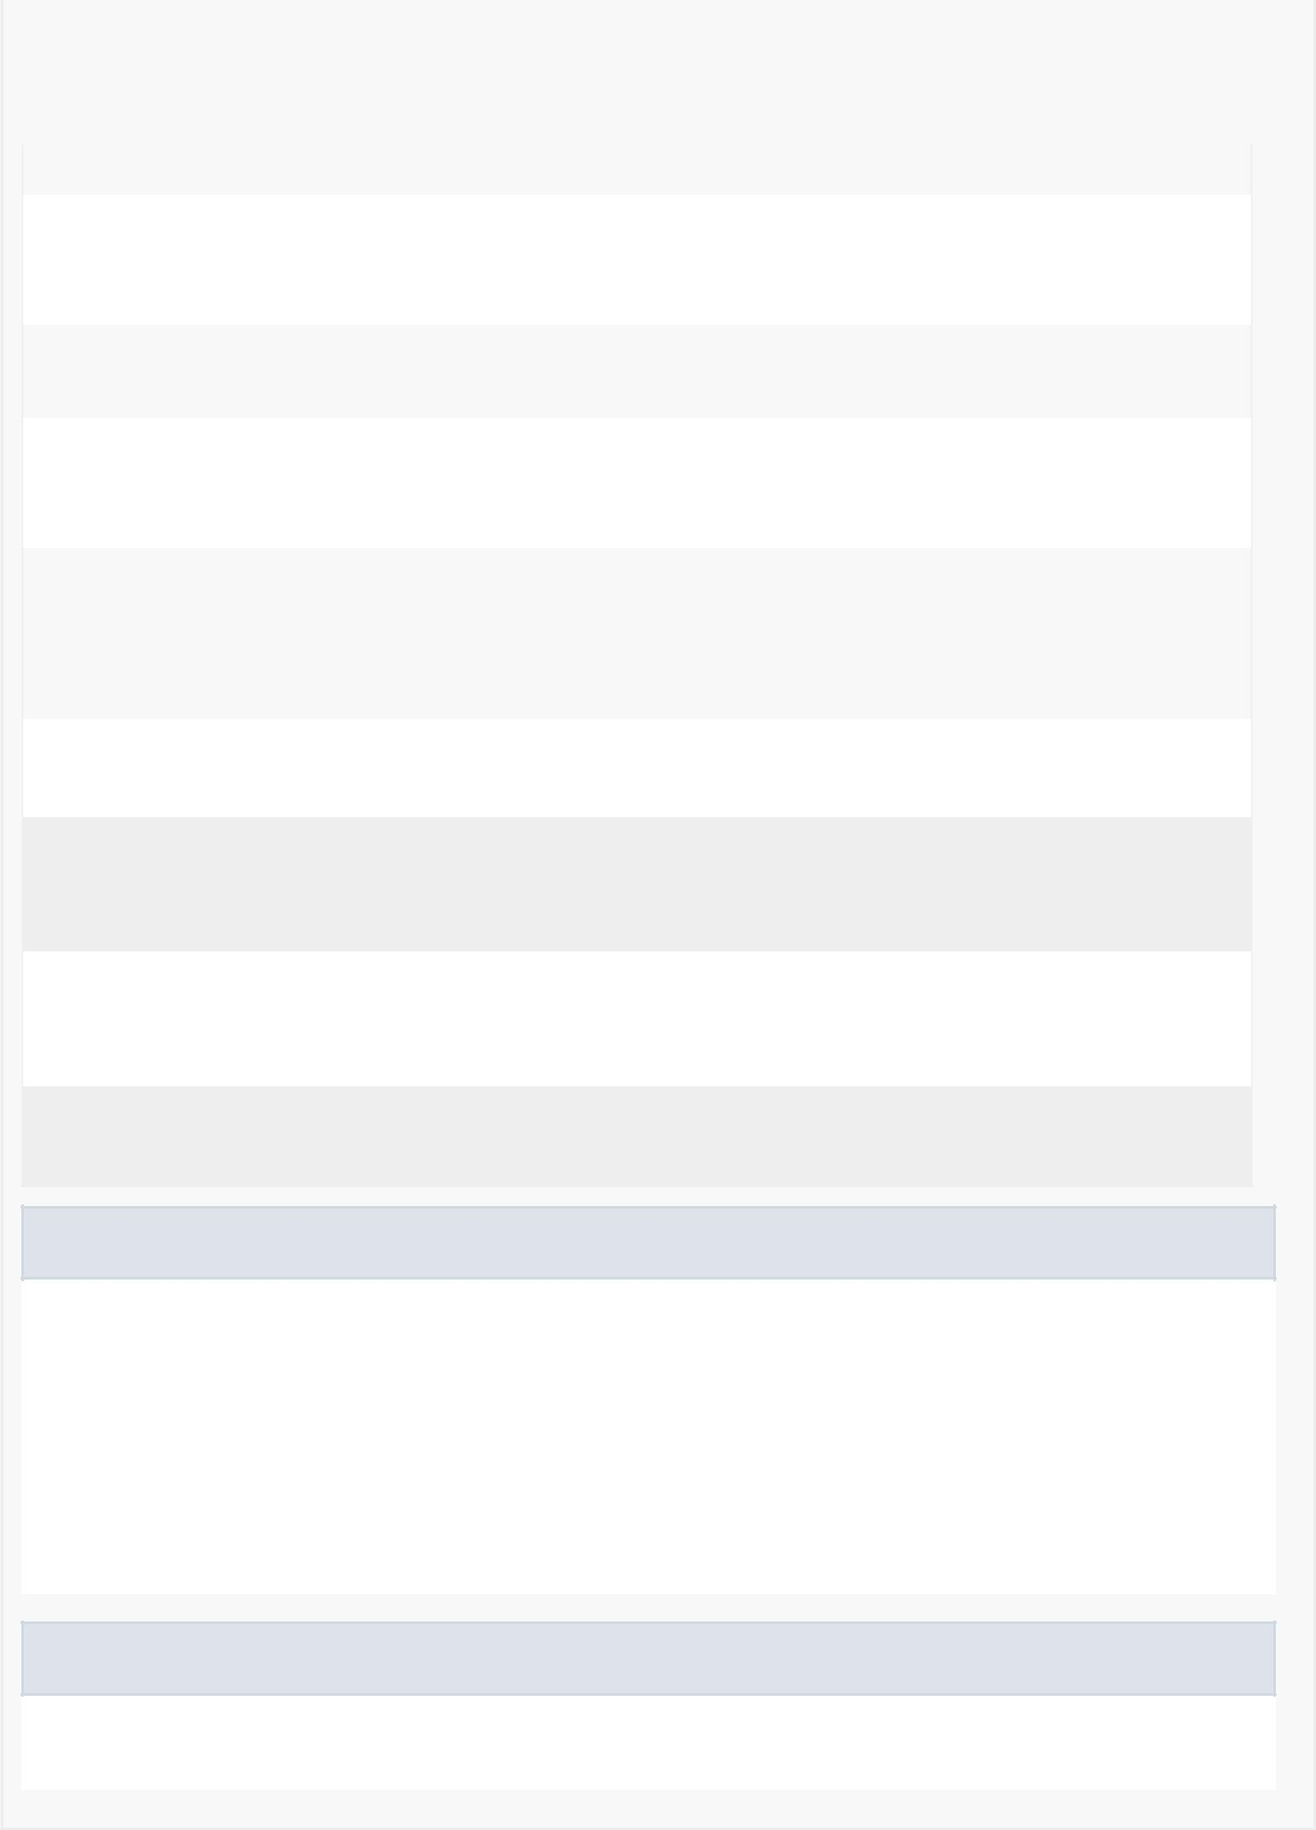

|  |  |  |  |  |  |  |  |  |  |  |
| --- | --- | --- | --- | --- | --- | --- | --- | --- | --- | --- |
| All Methods |  |  | [Static Methods](javascript:show(1);) | |  |  | [Instance Methods](javascript:show(2);) |  | [Concrete Methods](javascript:show(8);) |  |
| Modifier and Type | | |  | Method and Description | | | | |  |  |
| private int | | |  | adaptDayOfWeek(int weekday) | | | | |  |  |
|  |  |  |  | There's a mismatch between our original int values of weekdays with the | | | | | | |
|  |  |  |  | java.utils.calendar integer values of weekdays. | | | | | | |
|  |  |  | |  |  |  | |  |  |  |
| java.lang.String | | | | breakCalculator(User u, | | | | |  |  |
|  |  |  |  | java.util.ArrayList<Break> friendBreaks) | | | | | | |
| private void | | |  | checkBreakStatus(MyViewHolderFriend myViewHolderFriend,User u) | | | | | | |
|  |  |  |  | Gets the user's break status (time before a break, in break or no more | | | | | | |
|  |  |  |  | breaks). | | |  |  |  |  |
|  |  |  |  |  |  |  | |  | |  |
| static long | | |  | getDateDiff(java.util.GregorianCalendar date1, | | | | | | |
|  |  |  |  | java.util.GregorianCalendar date2, | | | | |  |  |
|  |  |  |  | java.util.concurrent.TimeUnit timeUnit) | | | | | | |
|  |  |  |  | Returns the difference between two dates in milliseconds. | | | | | | |
| int | | |  | getItemCount() | | |  |  |  |  |
|  |  |  |  | Returns the size of the list. | | | | |  |  |
| void | | |  | onBindViewHolder(MyViewHolderFriend myViewHolderFriend, | | | | | | |
|  |  |  |  | int position) | | |  |  |  |  |

Binds the information from a given friend with the ViewHolder.

MyViewHolderFriend onCreateViewHolder(android.view.ViewGroup viewGroup, int itemType)

Creates a Visual interpretation using a custom ViewHolder.

private void Poke(User user)

Pokes a given user.

Methods inherited from class android.support.v7.widget.RecyclerView.Adapter

bindViewHolder, createViewHolder, getItemId, getItemViewType, hasObservers, hasStableIds, notifyDataSetChanged, notifyItemChanged, notifyItemChanged, notifyItemInserted, notifyItemMoved, notifyItemRangeChanged, notifyItemRangeChanged, notifyItemRangeInserted, notifyItemRangeRemoved, notifyItemRemoved, onAttachedToRecyclerView, onBindViewHolder, onDetachedFromRecyclerView, onFailedToRecycleView, onViewAttachedToWindow, onViewDetachedFromWindow, onViewRecycled, registerAdapterDataObserver, setHasStableIds, unregisterAdapterDataObserver

Methods inherited from class java.lang.Object

clone, equals, finalize, getClass, hashCode, notify, notifyAll, toString, wait, wait, wait



*Field Detail*

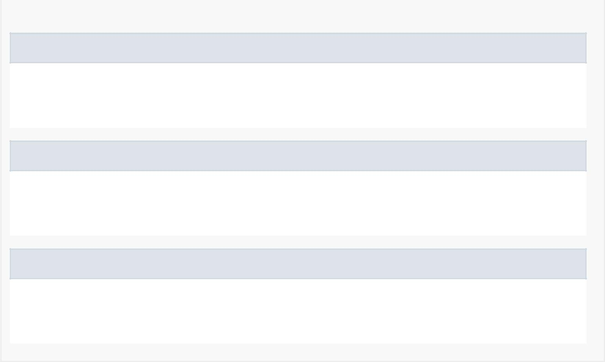

list

private java.util.List<User> list

Contains the list of the user's friends

context

private android.content.Context context

The context to the activity

isPokable

private boolean isPokable

Determines if the friend can be poked or not

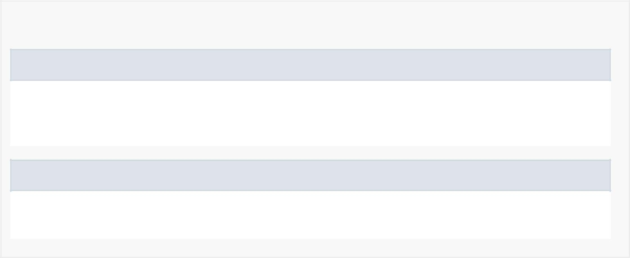

*Constructor Detail*

MyAdapterFriend

public MyAdapterFriend(java.util.List<User> list, android.content.Context context)

MyAdapterFriend

public MyAdapterFriend()

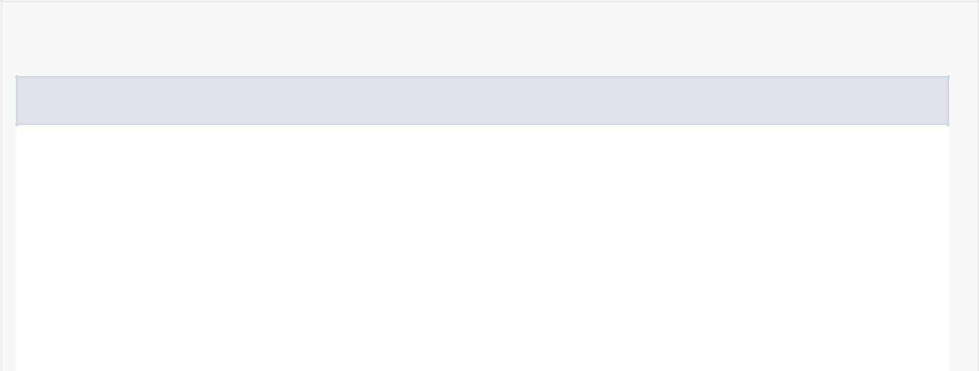

*Method Detail*

onCreateViewHolder

public MyViewHolderFriend onCreateViewHolder(android.view.ViewGroup viewGroup, int itemType)

Creates a Visual interpretation using a custom ViewHolder.

Specified by:

onCreateViewHolder in

class android.support.v7.widget.RecyclerView.Adapter<MyViewHolderFriend>

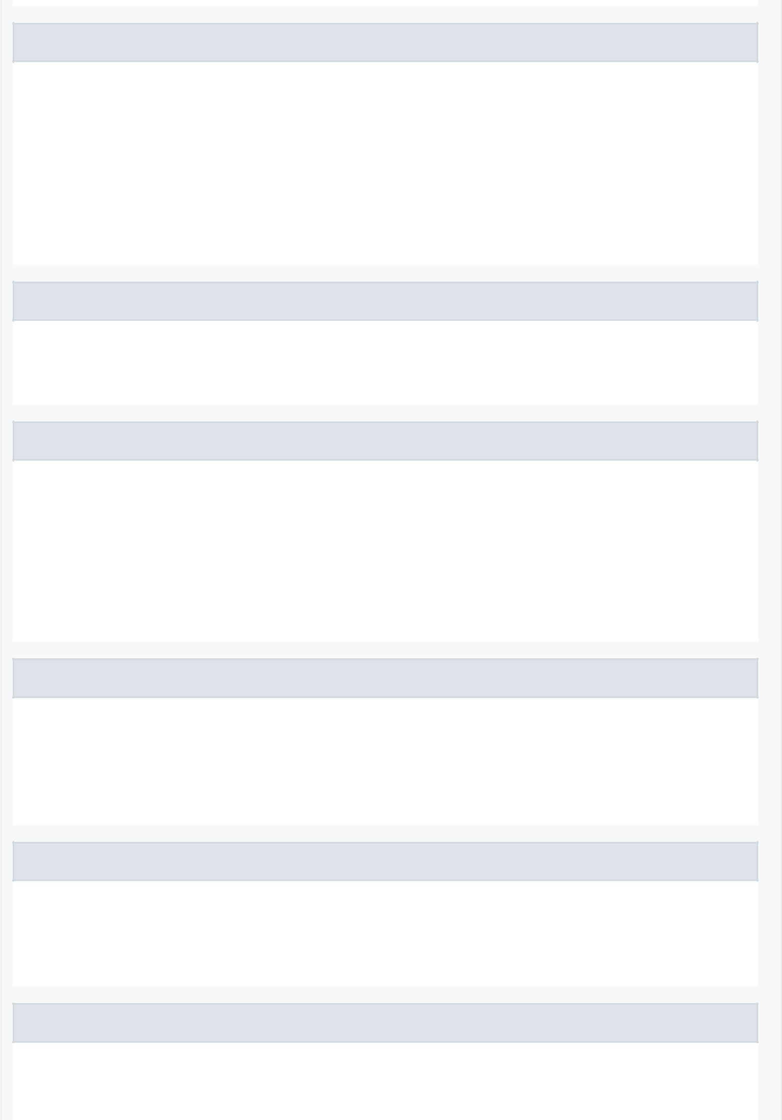onBindViewHolder

public void onBindViewHolder(MyViewHolderFriend myViewHolderFriend, int position)

Binds the information from a given friend with the ViewHolder.

Specified by:

onBindViewHolder in

class android.support.v7.widget.RecyclerView.Adapter<MyViewHolderFriend>

Poke

private void Poke(User user)

Pokes a given user.

getItemCount

public int getItemCount()

Returns the size of the list.

Specified by:

getItemCount in

class android.support.v7.widget.RecyclerView.Adapter<MyViewHolderFriend>

getDateDiff

public static long getDateDiff(java.util.GregorianCalendar date1, java.util.GregorianCalendar date2, java.util.concurrent.TimeUnit timeUnit)

Returns the difference between two dates in milliseconds.

checkBreakStatus

private void checkBreakStatus(MyViewHolderFriend myViewHolderFriend, User u)

Gets the user's break status (time before a break, in break or no more breaks).

breakCalculator

public java.lang.String breakCalculator(User u,

java.util.ArrayList<Break> friendBreaks)

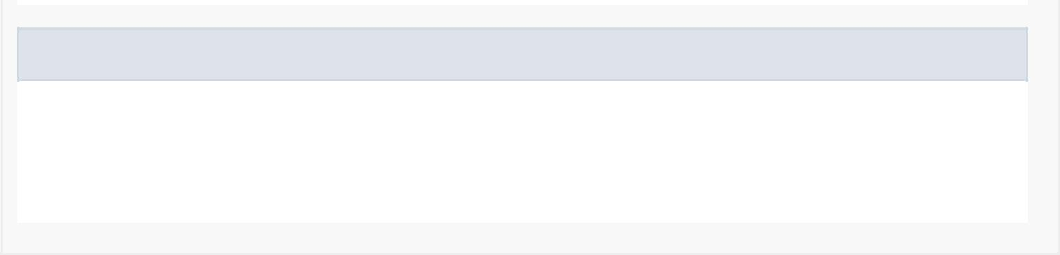adaptDayOfWeek

private int adaptDayOfWeek(int weekday)

There's a mismatch between our original int values of weekdays with the java.utils.calendar integer values of weekdays.